degree of eye openness is output simultaneously with the establishment or updating of the areas of eye presence. That value is used in judging whether the eyes are open or closed and also in judging whether the eyes have been detected correctly or not. If the system judges that the eyes have not been detected correctly, the routine returns to the detection of the entire face.
The first step is the image acquisition which is done by using video camera which takes the video of the driver and convert into image frames. The second step is the face detection, in this we use viola Jones algorithm to detect face Viola-Jones algorithm is based on exploring the input image by means of sub window capable of detecting features. This window is scaled to detect faces of different sizes in the image. Viola Jones developed a scale invariant detector which runs through the image many times, each time with different size. Being scale invariant, the detector requires same number of calculations regardless of the size of the image the third step is eyes detection. Similarly, Eyes are detected by using this algorithm. To detect eyes we first detect nose and then detect pair of eyes. However, the RGB model includes brightness in addition to the colours. When it comes to human’s eyes, different brightness for the same colour means different colour. When analysing a human eye, RGB model is very sensitive in image brightness. The next step is to extract the features of eyes i.e. to convert RGB image into YCBCR image: The Cb and Cr components give a good indication on whether a pixel is part of the skin or not. This can clearly be seen in Figure.8, which are the Cb and Cr values of all the pixels that are part of the eye. There is a strong correlation between the Cb and Cr values of skin pixels, to reveal the comparison between eyes and non-eyes in the YCbCr space. The next step is to calculate the mean and standard deviation of eyes i.e. for open, drowsy and close image.
The following explains the eye detection procedure in the order of the processing operations.
a) Preprocessing:
The preprocessing operations include the binarization of a facial image to increase the processing speed and conserve memory capacity and noise removal. The image processor developed for this drowsiness warning system performs the expansion and contraction operation on the white pixels and processing for noise removal is performed on the small black pixels of the facial images. After the binarization, the noise removal procedure involves an expansion processing method combined with the use of a median filter. These preprocessing operations are sufficient to support detection of the vertical positions of the eyes. However, following identification of the eye positions, the size of the eyes must be converted back to the original image format at the time the degree of eye openness is output. To facilitate that, data contraction is performed in the latter stage of preprocessing.
b) Face width detection:
The maximum width of the drivers face must be detected in order to determine the lateral positions of the areas in which the eyes are present. Face width is detected by judging the continuity of white pixels and the pattern of change in pixel number. On that basis, the outer edges of the face are recognized and determined.
c) Detection of vertical eye positions:
Each vertical eye position is detected independently within an area demarcated by the center line of the face, which is found from the face width, and straight lines running through the right and left outer edges of the face. In a binary image, the eye becomes collection of black pixels, along with the eyebrows, nostrils, mouth and other facial features. These collections of black pixels are recognized on the basis of a labeling operation, and the position of each eye is extracted by judging the area of each label along with its aspect ratio and relative coordinate positions in the facial image. Through this process of detecting each vertical eye position, the central coordinates of each eye are recognized. The coordinates serve as references for defining the areas of eye presence.
d) Eye tracking:
A function for tracking the positions of the eye is an important capability for achieving high-speed processing because it eliminates the need to process every frame in order to detect each eye position from the entire facial image. This function consists of a subordinate for updating the areas of eye presence and recognizing when tracking becomes impossible. The basic concept of eye tracking is to update the area of eye presence, in which an eye search is made in the following frame, according to the central coordinates of the eye in the previous frame. The updating process involves defining an arc of eye presence on the basis of the coordinates (xk, yk) at the point of intersection of center lines running through the Ferets diameter of the detected eye. The area thus becomes the area of eye presence in which the system searches for the eye in the image data of the next frame. This process of using information on eye position to define the eye position for obtaining the next facial image data makes it possible to track the position of the eye. As it is clear from this description, the size of the area of eye position changes. If the eyes are tracked correctly, their degree of openness will always vary within certain specified range for each individual driver. Consequently, if the value found by the system falls outside the range, it judges that the eyes are not being tracked correctly. The process of detecting the position of each eye from the entire facial image is then executed once more.
e) Judgment whether the eye are open/closed:
We constructed a template consisting of two circles, one inside the other. A good match would result in many dark pixels in the area inside the inner circle, and many bright pixels in the area between the two circles. This match occurs when the inner circle is centered on the iris and the outside circle covers the sclera. The match M (a1, a2) is computed as M (a1, a2) = I (p, q)- I (p, q) (p, q)a1 (p, q) a2 A low value for M (a1, a2) corresponds to a good match. The template is matched across the predicted eye-region, and the best match is reported. We track the eye by looking for the darkest pixel in the predicted region and thus the driver can be warned if found in drowsy state.
4.1.2 System Process
4.1.2.1. Eye detection function
An explanation is given here of the eye detection procedure. After inputting a facial image, pre-processing is first performed by binarizing the image. The top and sides of the face are detected to narrow down the area of where the eyes exist. Using the sides of the face, the centre of the face is found, which will be used as a reference when comparing the left and right eyes. Moving down from the top of the face, horizontal averages (average intensity value for each y coordinate) of the face area are calculated. Large changes in the averages are used to define the eye area. The following explains the eye detection procedure in the order of the processing operations. All images were generating in Matlab using the image processing toolbox.
Binarization
The first step to localize the eyes is binarizing the picture. Binarization is converting the image to a binary image. A binary image is an image in which each pixel assumes the value of only two discrete values. In this case the values are 0 and 1, 0 representing black and 1 representing white. With the binary image it is easy to distinguish objects from the background. Examples of binarized images are shown in Figure 4.2.

a) Threshold value 100. b) Threshold value 150.
c) Threshold value 200
Figure 4.2: Examples of binarization using different thresholds.
The grayscale image is converting to a binary image via thresholding. The output binary image has values of 0 (black) for all pixels in the original image with luminance less than level and 1 (white) for all other pixels. Thresholds are often determined based on surrounding lighting conditions, and the complexion of the driver. After observing many images of different faces under various lighting conditions a threshold value of 150 was found to be effective. The criteria used in choosing the correct threshold was based on the idea that the binary image of the driver’s face should be majority white, allowing a few black blobs from the eyes, nose and/or lips. Figure 4.2 demonstrates the effectiveness of varying threshold values. Figure 4.2a, 4.2b, and 4.2c use the threshold values 100, 150 and 200, respectively. Figure 4.2b is an example of an optimum binary image for the eye detection algorithm in that the background is uniformly black, and the face is primary white. This will allow finding the edges of the face, as described in the next section.

Face Top and Width Detection
The next step in the eye detection function is determining the top and side of the driver’s face. This is important since finding the outline of the face narrows down the region in which the eyes are, which makes it easier (computationally) to localize the position of the eyes. The first step is to find the top of the face. The first step is to find a starting point on the face, followed by decrementing the y-coordinates until the top of the face is detected. Assuming that the person’s face is approximately in the centre of the image, the initial starting point used is (100,240). The starting x-coordinate of 100 was chosen, to insure that the starting point is a black pixel (no on the face). The following algorithm describes how to find the actual starting point on the face, which will be used to find the top of the face.
1. Starting at (100,240), increment the x-coordinate until a white pixel is found. This is considered the left side of the face.
2. If the initial white pixel is followed by 25 more white pixels, keep incrementing x until a black pixel is found.
3. Count the number of black pixels followed by the pixel found in step2, if a series of 25 black pixels are found, this is the right side.
4. The new starting x-coordinate value (x1) is the middle point of the left side and right side.
Figure 4.3 demonstrates the above algorithm. Using the new starting point (x1, 240), the top of the head can be found. The following is the algorithm to find the top of the head:
1. Beginning at the starting point, decrement the y-coordinate (i.e.; moving up the face).
2. Continue to decrement y until a black pixel is found. If y becomes 0 (reached the top of the image), set this to the top of the head.
3. Check to see if any white pixels follow the black pixel.
i. If a significant number of white pixels are found, continue to decrement y.
ii. If no white pixels are found, the top of the head is found at the point of the 4.2a, 4.2b, and 4.2c use the threshold values 100, 150 and 200, respectively. Figure 4.2b is an example of an optimum binary image for the eye detection algorithm in that the background is uniformly black, and the face is primary white. This will allow finding the edges of the face, as described in the next section.

Face Top and Width Detection
The next step in the eye detection function is determining the top and side of the driver’s face. This is important since finding the outline of the face narrows down the region in which the eyes are, which makes it easier (computationally) to localize the position of the eyes. The first step is to find the top of the face. The first step is to find a starting point on the face, followed by decrementing the y-coordinates until the top of the face is detected. Assuming that the person’s face is approximately in the centre of the image, the initial starting point used is (100,240). The starting x-coordinate of 100 was chosen, to insure that the starting point is a black pixel (no on the face). The following algorithm describes how to find the actual starting point on the face, which will be used to find the top of the face.
1. Starting at (100,240), increment the x-coordinate until a white pixel is found. This is considered the left side of the face.
2. If the initial white pixel is followed by 25 more white pixels, keep incrementing x until a black pixel is found.
3. Count the number of black pixels followed by the pixel found in step2, if a series of 25 black pixels are found, this is the right side.
4. The new starting x-coordinate value (x1) is the middle point of the left side and right side.
Figure 4.3 demonstrates the above algorithm. Using the new starting point (x1, 240), the top of the head can be found. The following is the algorithm to find the top of the head:
1. Beginning at the starting point, decrement the y-coordinate (i.e.; moving up the face).
2. Continue to decrement y until a black pixel is found. If y becomes 0 (reached the top of the image), set this to the top of the head.
3. Check to see if any white pixels follow the black pixel.
i. If a significant number of white pixels are found, continue to decrement y.
ii. If no white pixels are found, the top of the head is found at the point of the initial black pixel.
Starting point (100,240)
A Count 25 white pixels from this point
B Count 25 black pixels from this point
x1 Middle point of A and B
Figure 4.3: Face top and width detection.
Once the top of the driver’s head is found, the sides of the face can also be found. Below are the steps used to find the left and right sides of the face.
1. Increment the y-coordinate of the top (found above) by 10. Label this y1 = y + top.
2. Find the centre of the face using the following steps:

i. At point (x1, y1), move left until 25 consecutive black pixels are found, this is the left side (lx).
ii. At point (x1, y1), move right until 25 consecutive white pixels are found, this is the right side (rx).
iii. The centre of the face (in x-direction) is: (rx – lx)/2. Label this x2.
3. Starting at the point (x2, y1), find the top of the face again. This will result in a new y-coordinate, y2.4. Finally, the edges of the face can be found using the point (x2, y2). i. Increment y-coordinat. ii. Move left by decrementing the x-coordinate, when 5 black consecutive pixels are found, this is the left side, add the x-coordinate to an array labeled ‘left_x’. iii. Move right by incrementing the x-coordinate, when 5 black consecutive pixels are found, this is the right side, add the x-coordinate to an array labeled ‘right_x’.iv. Repeat the above steps 200 times (200 different y-coordinates). The result of the face top and width detection is shown in Figure 4.4, these were marked on the picture as part of the computer simulation.
Figure 4.4:

Figure 4.4: Face edges found after first trial.
As seen in Figure 4.4, the edges of the face are not accurate. Using the edges found in this initial step would never localize the eyes, since the eyes fall outside the determined boundary of the face. This is due to the blobs of black pixels on the face, primarily in the eye area, as seen in Figure 4.2b. To fix this problem, an algorithm to remove the black blobs was developed.

Removal of Noise
The removal of noise in the binary image is very straightforward. Starting at the top, (x2,y2), move left on pixel by decrementing x2, and set each y value to white (for 200 y values). Repeat the same for the right side of the face. The key to this is to stop at left and right edge of the face; otherwise the information of where the edges of the face are will be lost. Figure 4.5, shows the binary image after this process.
Figure 4.5: Binary picture after noise removal.
After removing the black blobs on the face, the edges of the face are found again. As seen below, the second time of doing this results in accurately finding the edges of the face.
Figure 4.6: Face edges found after second trial.
Finding Intensity Changes on the Face
The next step in locating the eyes is finding the intensity changes on the face. This is done using the original image, not the binary image. The first step is to calculate the average intensity for each y – coordinate. This is called the horizontal average, since the averages are taken among the horizontal values. The valleys (dips) in the plot of the horizontal values indicate intensity changes. When the horizontal values were initially plotted, it was found that there were many small valleys, which do not represent intensity changes, but result from small differences in the averages. To correct this, a smoothing algorithm was implemented. The smoothing algorithm eliminated and small changes, resulting in a more smooth, clean graph. After obtaining the horizontal average data, the next step is to find the most significant valleys, which will indicate the eye area. Assuming that the person has a uniform forehead (i.e.; little hair covering the forehead), this is based on the notion that from the top of the face, moving down, the first intensity change is the eyebrow, and the next change is the
upper edge of the eye, as shown below.
First significant intensity change
Second significant intensity change
Top of the head
Figure 4.7: Labels of top of head, and first two intensity changes.
The valleys are found by finding the change in slope from negative to positive. And peaks are found by a change in slope from positive to negative. The size of the valley is determined by finding the distance between the peak and the valley. Once all the valleys are found, they are sorted by their size.

Detection of Vertical Eye Position
The first largest valley with the lowest y – coordinate is the eyebrow, and the second largest valley with the next lowest y-coordinate is the eye. This is shown in Figures 4.8a and 4.8b.
a) Graph of horizontal averages of the left side of the face.
b) Position of the left eye found from finding the valleys in a).
Figure 7.8: Result of using horizontal averages to find vertical position of the eye.

This process is done for the left and right side of the face separately, and then the found eye areas of the left and right side are compared to check whether the eyes are found correctly. Calculating the left side means taking the averages from the left edge to the centre of the face, and similarly for the right side of the face. The reason for doing the two sides separately is because when the driver’s head is tilted the horizontal averages are not accurate. For example if the head is tilted to the right, the horizontal average of the eyebrow area will be of the left eyebrow, and possibly the right hand side of the forehead.
4.1.2.2. Drowsiness Detection Function
Determining the State of the Eyes
The state of the eyes (whether it is open or closed) is determined by distance between the first two intensity changes found in the above step. When the eyes are closed, the distance between the y – coordinates of the intensity changes is larger if compared to when the eyes are open. This is shown in Figure 4.9.

Figure 4.9: Comparison of open and closed eye
The limitation to this is if the driver moves their face closer to or further from the camera. If this occurs, the distances will vary, since the number of pixels the face takes up varies, as seen below. Because of this limitation, the system developed assumes that the driver’s face stays almost the same distance from the camera at all times.

Judging Drowsiness
When there are 5 consecutive frames find the eye closed, then the alarm is activated, and a driver is alerted to wake up. Consecutive number of closed frames is needed to avoid including instances of eye closure due to blinking. Criteria for judging the alertness level on the basis of eye closure count is based on the results found in a previous study [9].
4.2. Algorithm Implementation:
4.2.1. Real-time System
The real-time system includes a few more functions when monitoring the driver, in order to make the system more robust. There is an initialization stage, in which the for the first 4 frames, the driver’s eyes are assumed to be open, and the distance between the y coordinates of where the intensity changes occur, is set as a reference. After the initialization stage, the distances calculated are compared with the one found in the initialization stage. If the lower distance is found (difference between 5-80 pixels), then the eye is determined as being closed. Another addition to the real-time system is a comparison of the left and right eyes found. The left and right eyes are found separately, and their positions are compared. Assuming that the driver’s head is not at an angle (tilted), the y – coordinates of the left and right eye should be approximately the same. If they are not, the system determines that the eyes have not been found, and outputs a message indicating that the system is not monitoring the eyes. The system then continues to try to find the eyes. This addition is also useful in cases where the driver is out of the camera’s sight. In this case, the system should indicate that no drowsiness monitoring is taking place. In the instance where there are 5 or more consecutive frames where the eye is not found, an alarm goes off. This takes account for the case when the driver’s head has completely dropped down, and hence an alarm is needed to alert the driver.
4.2.2. Challenges
4.2.2.1 Obtaining the image
The first, and probably most significant challenge faced was transferring the images obtained from the camera to the computer. Two issues were involved with this challenge: 1) Capturing and transferring in real time; 2) Having access to where the image was being stored. Initially, the ‘Dirt Cheap Frame Grabber’ was constructed and tested. It was later found that this hardware (which uses the parallel port) would not be fast enough, and it would be difficult to write software to process the images in conjunction with the hardware.

4.2.2.2 Constructing an effective light source
Illuminating the face is an important aspect of the system. Initially, a light source consisting of 8 IR LEDs and a 9V battery was constructed and mounted onto the camera. It was soon realized that the source was not strong enough. After review other literature, the conclusion was that in order to build a strong enough light source, approximately 50 LEDs. To reduce the cost, a desk lamp and IR filter were used (as described previously).

4.2.2.3 Determining the correct binarization threshold
Because of varying facial complexions and ambient light, it was very hard to determine the correct threshold for binarization. The initial thought was to choose a value that would result in the least amount of black blobs on the face. After observing several binary images of different people, it was concluded that a single threshold that would result in similar results for all people is impossible.
Histogram equalization was attempted, but resulted in no progress. Finally it was decided that blobs on the face were acceptable, and an algorithm to remove such blobs was developed.

4.2.2.4 Not being able to use edge detection algorithms
After reading many technical papers and image processing textbooks, it was though that locating the eyes would be a trivial task if edge detection were used. This notion turned out to be incorrect. A Sobel edge detection program was written and tested in C. Figure 4.10 shows the result. As can see, there are too many edges to find the outline of the face. Figure 4.10b shows the result of the eye area alone. It was also thought that in order to determine whether the eye was open or closed, an image processing algorithm to find circles could be used. That is, the absence of a circle would mean that the eye is closed. This also failed since many times the circle representing the iris was broken up. In addition, in order to use a circle finding algorithm, the radius of the circle must be known, and this varies depending on the distance of the driver from the camera.
a) Whole image. b) Eye area.

Figure 4.10: Results of using Sobel edge detection.
4.2.2.5 Case when the driver’s head is tilted
As mentioned previously, if the driver’s head is tilted, calculating the horizontal averages from the left side of the head to the right side is not accurate. It is not realistic to assume that the driver’s head will be perfectly straight at all times. To compensate for this, the left and right horizontal averages are found separately.

4.2.2.6 Finding the top of the head correctly
Successfully finding the top of the head was a big challenge. Depending on the binarization of the face, the top of the head could not be found correctly. The problem was with the black pixels on the face of the binary image. In some instances the nose, eye or lips were found to be the top of the head due to their black blobs in the binary image. Driver’s with facial hair were also often a source of this error. After implementing the noise removal algorithm, this problem was eliminated.

4.2.2.7 Finding bounds of the functions
By observing the system algorithm and source code, many bounds are defined. For example, when finding the edge of the face, 200 points in the y-direction is used. This represents the approximate length of the face from the top of the head (for a given distance from the camera). Another example is counting 25 points to the left and right of the centre point, when finding the edge of the face. This represents the approximate width of the face. Both of these values, along with other bounds were a challenge to determine. After examining many images of different faces, and testing different values, these bounds were determined.
4.3. Experimental Analysis:
.

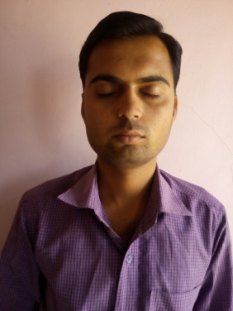

Photo 4.1: Snapshot of the system showing open and closed eye
Above photo shows simulation results of the system after Image captured by camera.
The captured image then convert into binarization by using V-J algorithm shown below;
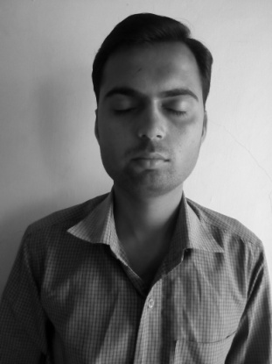
Photo 4.2: Snapshot of the system after binarization(Gray Image)
After conversion gray image the Eye detection occurs and we get Histogram of eyes.


Photo 4.3: Snapshot of the system after closed eye and it’s histogram


Photo 4.4: Snapshot of the system after open eye and it’s histogram

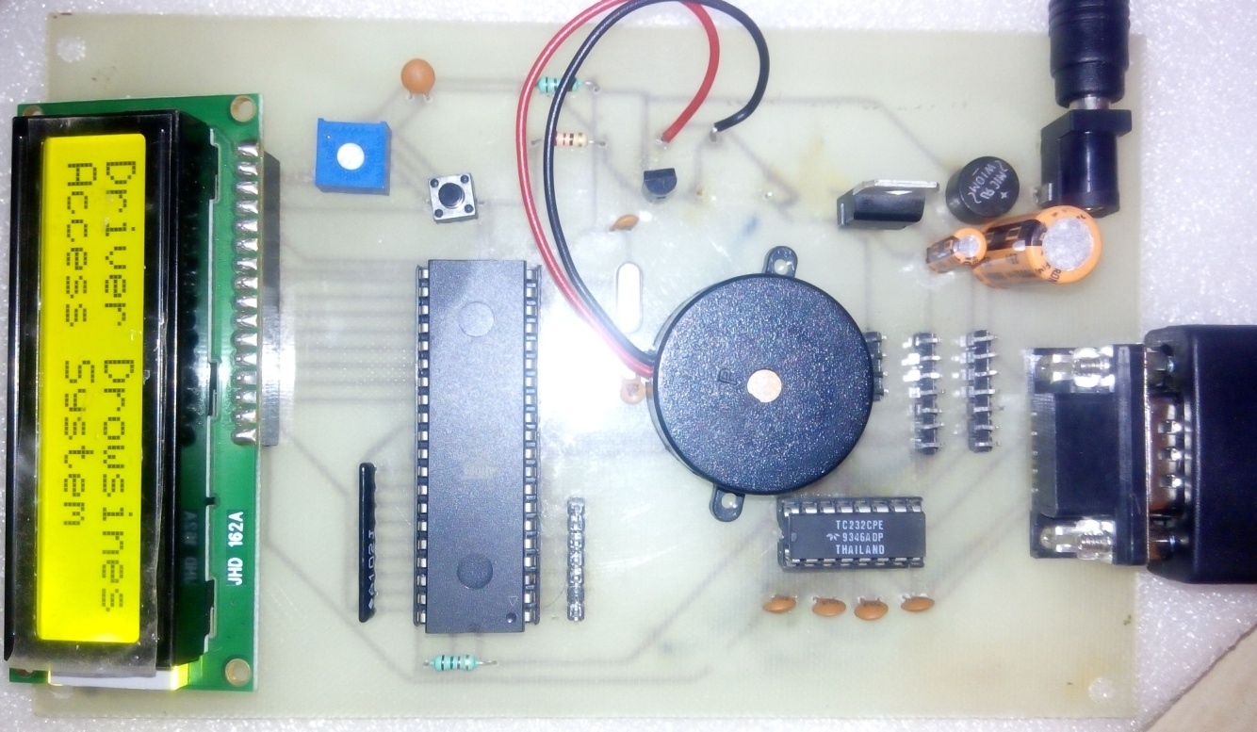
Photo 4.5: Snapshot of Drowsy Detection System

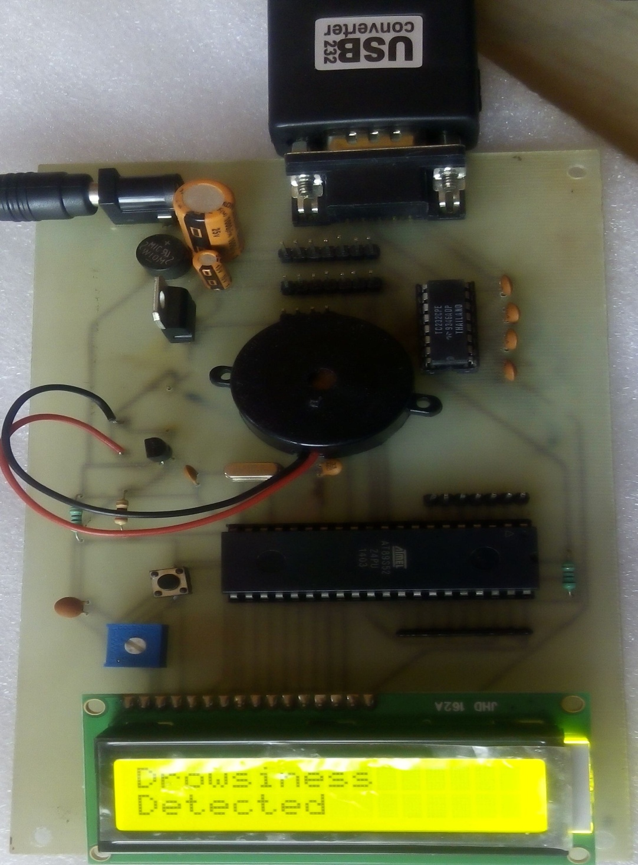

Photo 4.6: Snapshot of the system showing Drowsiness Detection on LCD display
Above photo shows results of the system on LCD. Drowsiness detected when eyes are closed.

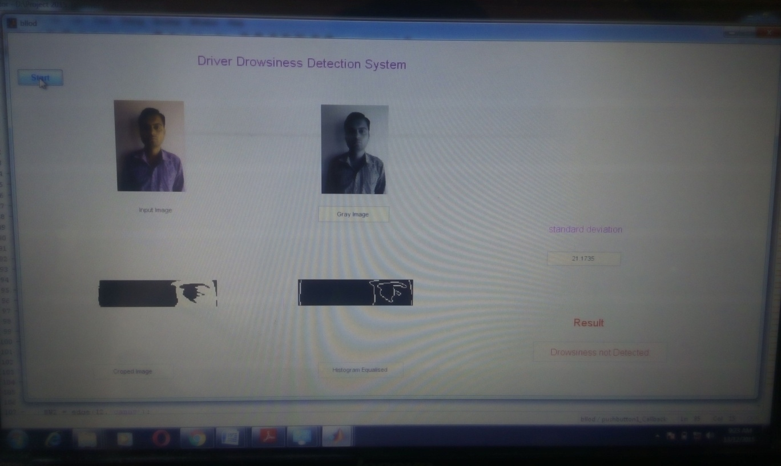
Photo 4.7: Snapshot of the system simulation showing Driver is in normal mode

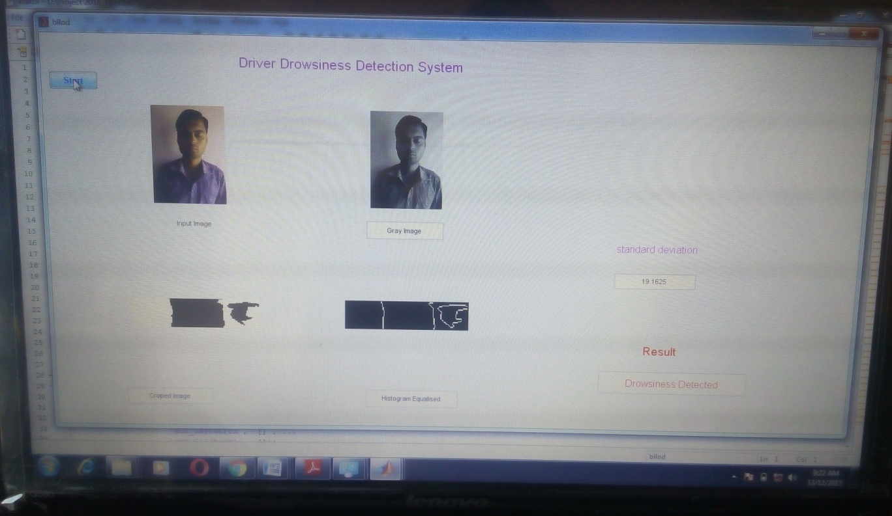
Photo 4.8: Snapshot of the system simulation showing Driver is in drowsy mode

4.4. Comparison with other approaches
This project gives a different way of approaching the problem. Eyes can be detected easily. Again accident location can also be located easily and the detection of violation is precise here unlike the prior approaches, where detection of violation is done by either of by using enforcement. Other driver detection system had developed but that used EEG and ECG methods for detecting driver is in drowsy or normal mode.
4.5. Justification:
From the previous researches it was observed that systems have addressed certain weaknesses and their paper has presented a reliable, effective and low cost system using EEG and ECG for detecting Drivers eyes. However, there are still scope for further refinements in the system.
Proposed system includes not only the detection but also speed control of vehicle through zigbee. This alerting, recording, reporting and controlling system is composed of a transmitter and receiver section, where transmitter will be fixed at particular lane or zone. The LCD displays the driver in Drowsy or in Normal mode and warning alert signal (Buzzer) will ON.
A solution is provided here to monitor cars everywhere without assigning a policemen and wasting man force on such issues. The Drivers are made aware of their driving behavior and violations made so that careful and conscious driving can be achieved.

